|  |  |
| --- | --- |
| Lab 6 Report | Antonio Zavala Anaya  UTEP ID 80622587 |

|  |
| --- |
| Project Name: Lab_6 (GitHub Repo)December 2019 |
| * Purpose: Write a Python 3 program that:   + Implement the following graph algorithms: * Kruskal’s algorithm * Topological sort |
| * Process:   + Implement the Disjoint set forest and graph data structures used by the instructor in class to generate a Kruskal’s algorithm as well as the topological sort.   + Follow the formula for both methods to implement it into a python program.   + After all the methods are made generate test cases to see if the programs are doing what they should following the formulas. |
| * Files used that will be used: * Graph_al.py * Kruskals_algorithm.py * Main.py * Queue.py * Topological_sort.py |

* Lab_5 program codes
* **Kruskal’s Algorithm**

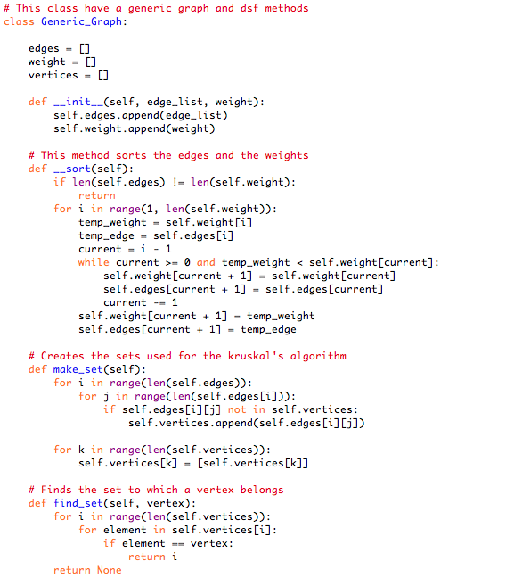



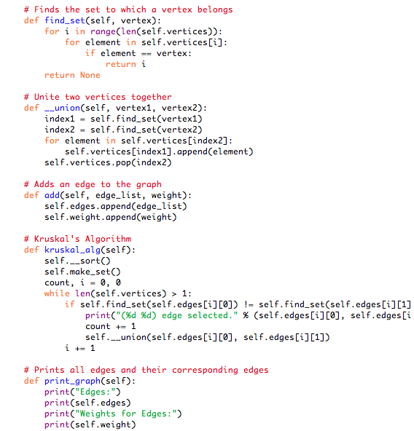



* **Topological Sort**

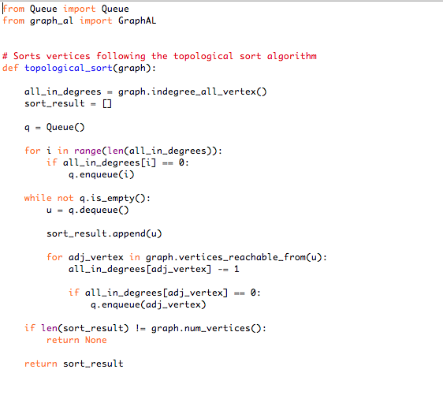

* Test Cases
* Kruskals Algoithm

Test case:

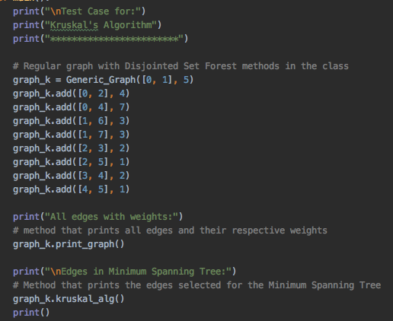

Result:

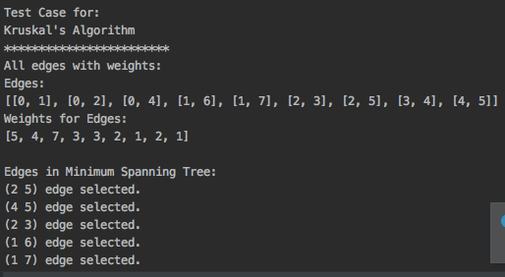

* Topological Sort

Test case:

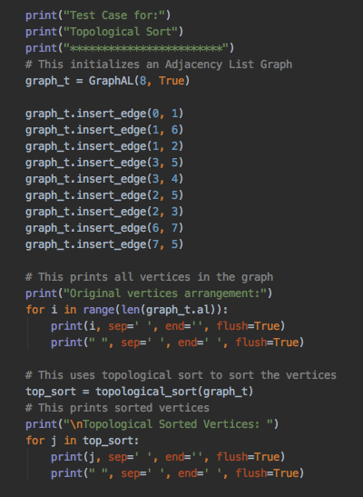

Result:

